Web data extraction Requirement document

Suggested Code Policy:

1. Copy the Project folder structure from bellow github link.

<https://github.com/hackathonScrapping/BANK.git>

1. Use Python(Mandatory) with BeautifulSoup, Scrapy and Selenium (Feel free to use any other Python libraries)
2. Store Scrapped data with provided file name and CSV format.

Work 1:

**Scarped Data Format (File Name - CoOp_Data_Deposit_<YYYY_MM_DD>.csv)**

|  |  |  |  |  |  |  |  |  |  |
| --- | --- | --- | --- | --- | --- | --- | --- | --- | --- |
| Date | Bank Name | Product Type | Product Name | Bank Offer | Account  Opening Balance | Minimum  Balance | Maximum Balance | Rate % | AER % |
|  |  | Offline |  |  |  |  |  |  |  |
|  |  |  |  |  |  |  |  |  |  |
|  |  |  |  |  |  |  |  |  |  |
|  |  |  |  |  |  |  |  |  |  |
|  |  |  |  |  |  |  |  |  |  |
|  |  |  |  |  |  |  |  |  |  |

[**https://www.co-operativebank.co.uk/savings/interest-rates**](https://www.co-operativebank.co.uk/savings/interest-rates)

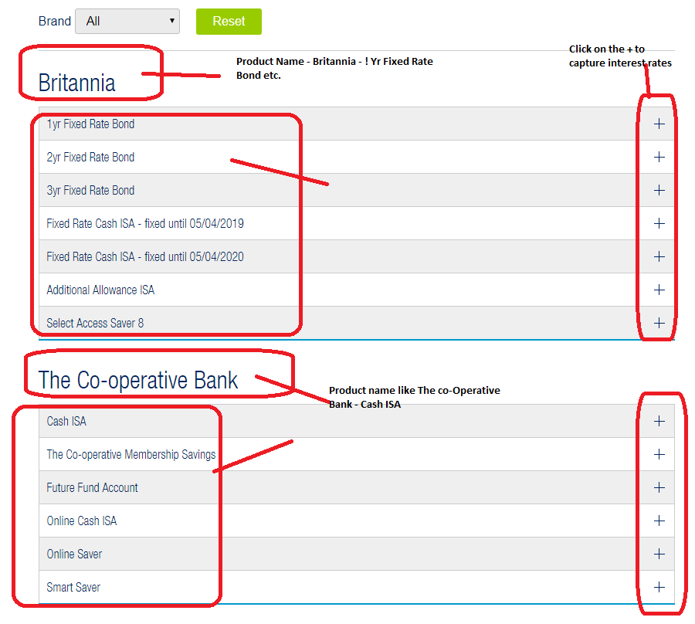

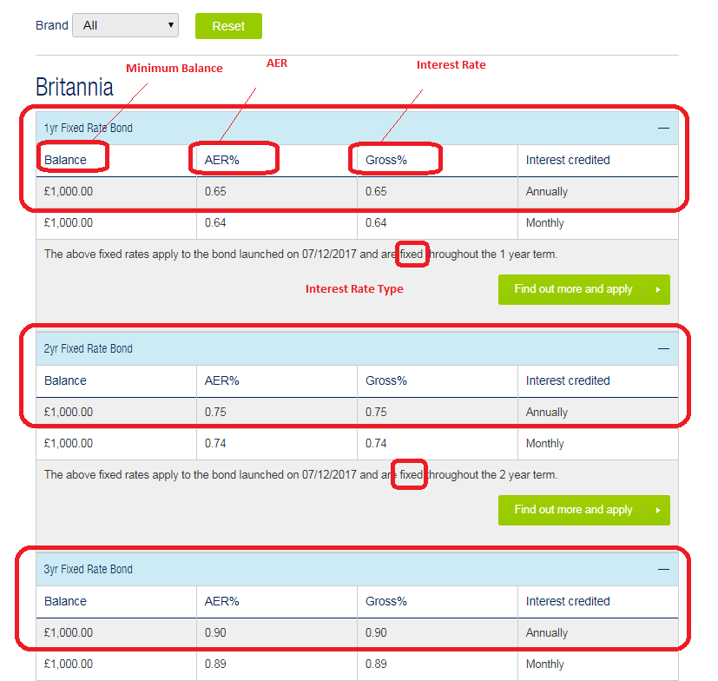

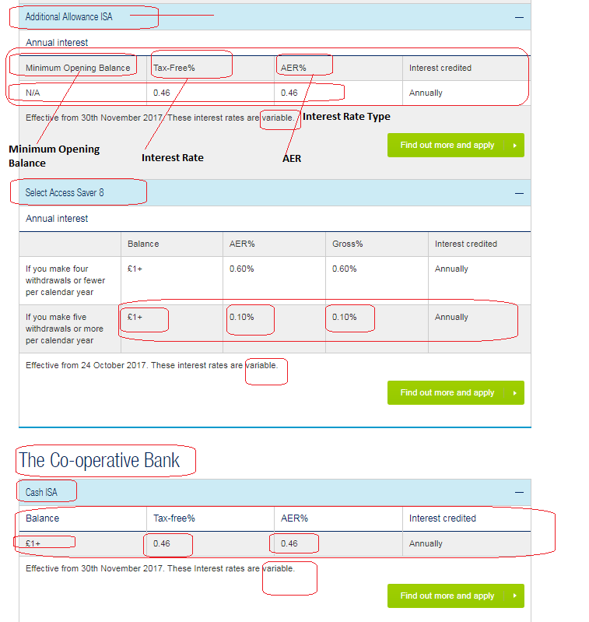

[**https://www.co-operativebank.co.uk/currentaccounts/compare-current-accounts**](https://www.co-operativebank.co.uk/currentaccounts/compare-current-accounts)

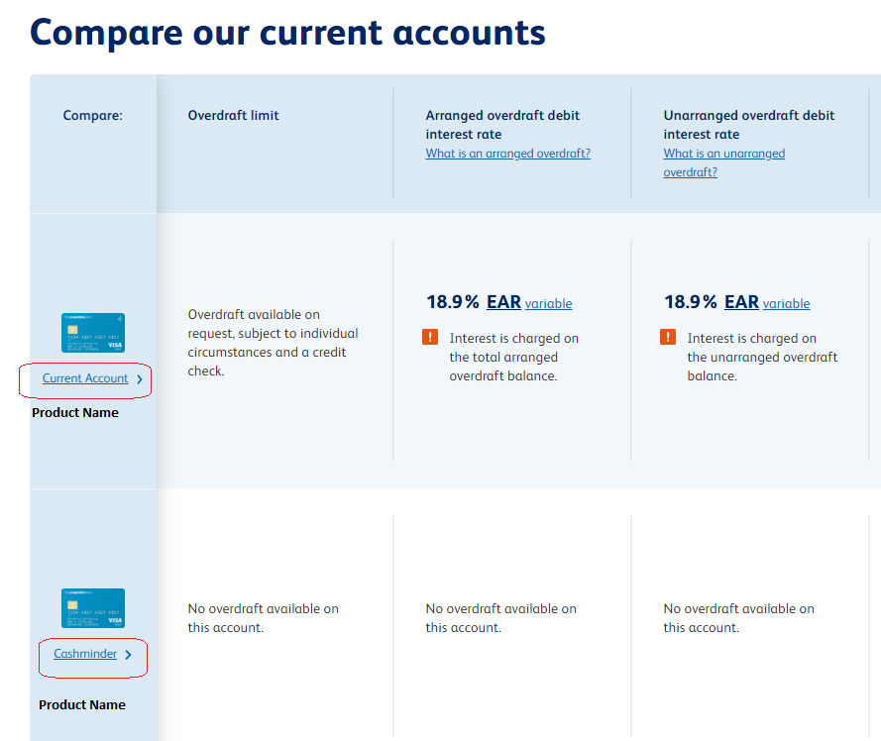

Work 2: Mortgage Rates

|  |  |  |  |  |  |  |  |  |  |
| --- | --- | --- | --- | --- | --- | --- | --- | --- | --- |
| Date | Bank Name | Product Type | Product Name | Loan amount | Mortgage Amount | Interest Tenor | Interest type | Rate % | APRC % |
|  |  | Offline |  |  |  |  |  |  |  |
|  |  |  |  |  |  |  |  |  |  |
|  |  |  |  |  |  |  |  |  |  |
|  |  |  |  |  |  |  |  |  |  |
|  |  |  |  |  |  |  |  |  |  |
|  |  |  |  |  |  |  |  |  |  |

<https://www.co-operativebank.co.uk/mortgages/existing-customers-moving-rates>

